Gradient and Second-Order Methods

Table of Contents
What are Gradient and Second-Order Methods? 1
Where Are They Used? 1
Why Use These Methods? 1
How Do These Methods Work? 2
Numerical Example: Minimizing f(x)=x2+4x+4f(x) = x^2 + 4x + 4f(x)=x2+4x+4 2
First-Order Derivative vs. Second-Order Derivative: Key Insights and Demos 4
1st Order Derivative: Gradient 4
Gradient Methods: 5
1. Gradient Descent: 5
2. Stochastic Gradient Descent (SGD): 5
3. Momentum-Based Gradient Descent: 6
Second-Order Methods: 6
1. Newton's Method: 6
2. Quasi-Newton Methods: 7
3. Comparison to First-Order Methods: 7
Applications in Python: 7

What are Gradient and Second-Order Methods?
- Gradient-based methods (using the first derivative) are optimization techniques used to find the minimum or maximum of a function.
- Second-order methods (using second derivatives) provide information on the curvature of the function for faster convergence.

Where Are They Used?
- Gradient-Based Methods:
  - Used in machine learning, neural network training, regression models, and clustering algorithms.
  - Applications include minimizing error/loss functions in supervised learning or maximizing likelihood in probabilistic models.
- Second-Order Methods:
  - Used in scenarios requiring high precision, such as financial modeling, physics simulations, and control systems.
  - Often applied in small-scale optimization problems or when computational resources are sufficient.

Why Use These Methods?
- Gradient Methods:
  - Simpler and computationally efficient.
  - Suitable for large-scale problems with many variables.
- Second-Order Methods:
  - Achieve faster convergence.
  - Handle non-linear problems more effectively.

How Do These Methods Work?
- Gradient Methods:
  - Follow the direction of the steepest descent (negative gradient) to reach the minimum.
- Second-Order Methods:
  - Use curvature (second derivative) to adjust step size and direction, leading to more precise solutions.

Numerical Example: Minimizing f(x)=x2+4x+4f(x) = x^2 + 4x + 4f(x)=x2+4x+4
Let’s solve the problem using gradient and second-order methods.
- First Derivative (Gradient):
f′(x)=2x+4f'(x) = 2x + 4f′(x)=2x+4
  - Gradient tells us the slope at a point.
  - For f′(x)=0f'(x) = 0f′(x)=0, solve 2x+4=02x + 4 = 02x+4=0, so x=−2x = -2x=−2.
- Second Derivative (Curvature):
f′′(x)=2f''(x) = 2f′′(x)=2
  - Hessian confirms f′′>0f'' > 0f′′>0, indicating a convex function (minimum at x=−2x = -2x=−2).
- Step-by-Step Gradient Descent:
  - Start with an initial guess (x0=0x_0 = 0x0​=0).
  - Update xt+1=xt−ηf′(xt)x_{t+1} = x_t - \eta f'(x_t)xt+1​=xt​−ηf′(xt​) where η=0.1\eta = 0.1η=0.1 (learning rate).
  - Iteratively: x1=0−0.1(2(0)+4)=−0.4x_1 = 0 - 0.1(2(0) + 4) = -0.4x1​=0−0.1(2(0)+4)=−0.4 x2=−0.4−0.1(2(−0.4)+4)=−0.76x_2 = -0.4 - 0.1(2(-0.4) + 4) = -0.76x2​=−0.4−0.1(2(−0.4)+4)=−0.76
    - Continue until f′(xt)≈0f'(x_t) \approx 0f′(xt​)≈0.

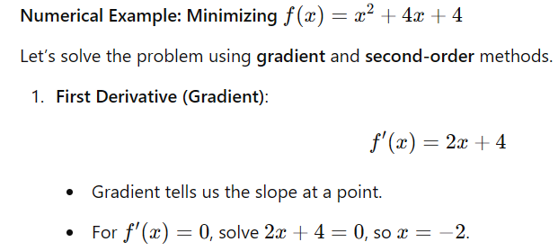
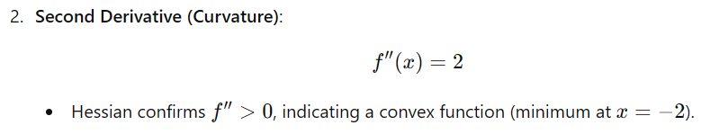
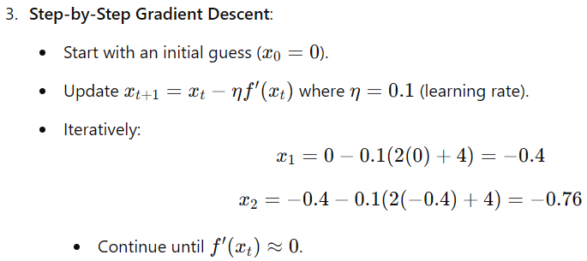
# Gradient descent example
import numpy as np

# Function and its gradient
def f(x):
return x**2 + 4*x + 4

def grad_f(x):
return 2*x + 4

# Gradient descent
x = 0 # Initial guess
eta = 0.1 # Learning rate
for _ in range(10):
x = x - eta * grad_f(x)
print(f"x: {x}, f(x): {f(x)}")

x: -0.4, f(x): 2.56
x: -0.7200000000000001, f(x): 1.6383999999999999
x: -0.976, f(x): 1.0485760000000002
x: -1.1808, f(x): 0.6710886399999998
x: -1.34464, f(x): 0.42949672959999985
…
x: -1.9999999646630588, f(x): 1.3322676295501878e-15
x: -1.999999971730447, f(x): 8.881784197001252e-16
x: -1.9999999773843578, f(x): 4.440892098500626e-16
x: -1.9999999819074863, f(x): 4.440892098500626e-16
x: -1.9999999855259891, f(x): 0.0
x: -1.9999999884207913, f(x): 0.0

First-Order Derivative vs. Second-Order Derivative: Key Insights and Demos

1st Order Derivative: Gradient
- What it does:
  - The first-order derivative measures the slope of a function.
  - It tells us whether the function is increasing or decreasing at a given point.
- How it is used:
  - Minimization: Moves in the direction of steepest descent (negative gradient) to find a minimum.
  - Maximization: Moves in the direction of steepest ascent (positive gradient) to find a maximum.
- Why it often leads to a minimum in ML:
  - In machine learning, we typically minimize the loss function (e.g., Mean Squared Error or Cross-Entropy Loss).
  - The optimization objective is designed to reduce the error.

2nd Order Derivative: Curvature (Hessian)
- What it does:
  - The second-order derivative measures the rate of change of the slope (curvature).
  - It tells us how steep or flat the slope is and whether a critical point is a minimum, maximum, or saddle point:
    - f′′(x)>0f''(x) > 0f′′(x)>0: Convex function, minimum at critical point.
    - f′′(x)<0f''(x) < 0f′′(x)<0: Concave function, maximum at critical point.
    - f′′(x)=0f''(x) = 0f′′(x)=0: Saddle point (neither a min nor a max).
- How it is used:
  - Second-order methods use curvature information to adjust the step size and direction for faster convergence.
  - Example: Newton's Method.

Demo: Using First and Second Derivatives

Example Function: f(x)=x3−3x2+2f(x) = x^3 - 3x^2 + 2f(x)=x3−3x2+2
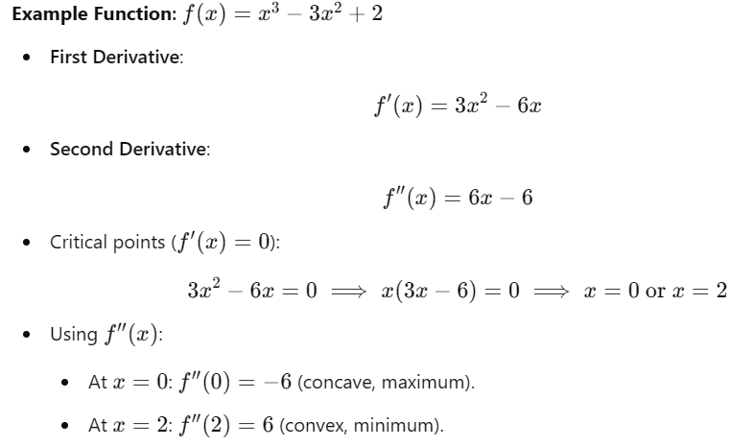

Python Demo: Gradient vs. Second-Order Analysis

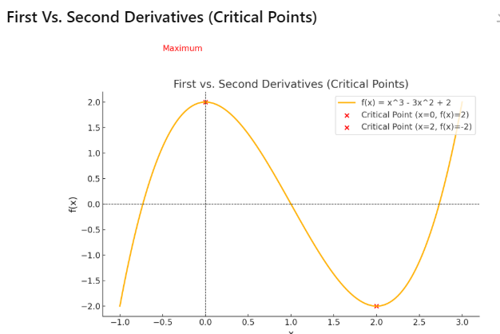

Explanation of the Plot:
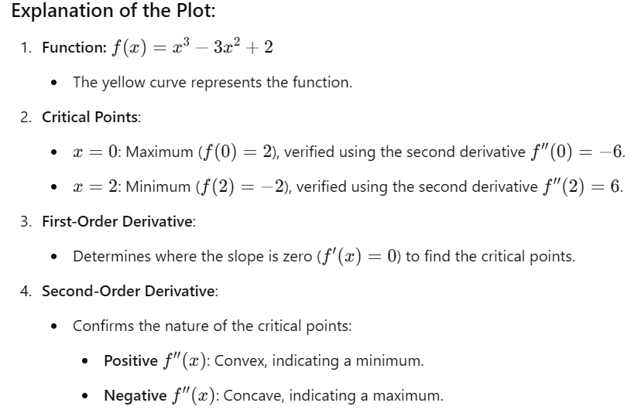

When to Use First vs. Second Derivatives?
- First-Order Derivatives:
  - Commonly used for optimization tasks (e.g., gradient descent) when a rough solution is acceptable.
- Second-Order Derivatives:
  - Used for precise solutions in small-scale problems or when curvature information significantly improves convergence speed.

Gradient Methods:
Gradient-based optimization methods use first-order derivatives (gradients) to iteratively find the minimum or maximum of a function.

1. Gradient Descent:
- Formula:
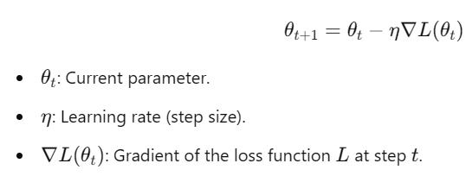
- Explanation:
  - Moves in the direction of the negative gradient to minimize the loss function.
  - Used in training machine learning models (e.g., linear regression, neural networks).
- Limitations:
  - Computationally expensive for large datasets.
  - May get stuck in local minima.

2. Stochastic Gradient Descent (SGD):
- Formula:
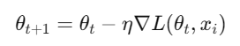

  - Instead of computing the gradient for the entire dataset, SGD calculates it for a randomly selected data point xix_ixi​.
- Advantages:
  - Faster computation.
  - Efficient for large-scale datasets.
- Disadvantages:
  - Noisy updates can lead to instability.

3. Momentum-Based Gradient Descent:
- Formula:
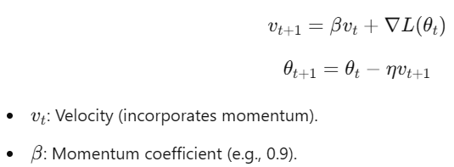
- Explanation:
  - Adds momentum to reduce oscillations and improve convergence speed.
  - Helps in overcoming shallow local minima.
- Python Libraries:
  - scipy.optimize for general-purpose optimization.
  - Optimizers in PyTorch and TensorFlow include SGD and Momentum.

Second-Order Methods:
Second-order methods utilize the second derivative (Hessian) to model the curvature of the loss function for optimization.

1. Newton's Method:
- Formula:
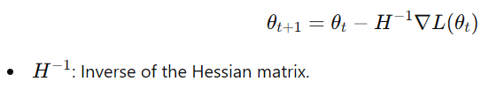
- Explanation:
  - Accounts for the curvature of the loss function.
  - Faster convergence to the minimum compared to gradient descent.
- Disadvantages:
  - Computationally expensive for large datasets (requires calculating and inverting the Hessian).

2. Quasi-Newton Methods:
- Approximate the Hessian to reduce computational costs.
- Example: BFGS Algorithm (used in scipy.optimize.minimize).

3. Comparison to First-Order Methods:
- First-Order Methods:
  - Use gradient (slope).
  - Require more steps for convergence.
  - Simpler and computationally cheaper.
- Second-Order Methods:
  - Use both gradient and curvature.
  - Achieve faster convergence.
  - Computationally intensive.

Applications in Python:
- Gradient Descent:
  - Libraries: scikit-learn, TensorFlow, PyTorch.
  - Optimizers: SGD, Adam, Momentum.
- Second-Order Methods:
  - Library: scipy.optimize.minimize.
  - Method: Use "Newton-CG" or "BFGS".

